# information

Analysis : what will I do 20-30pg (February half term )

Design : how I will do it 40pg( 20th march )

Development: making it 100-200pg(Friday Flo’s bday, latest half term )

Testing - approx. 50 pages(by November exeat )

Evaluation - 5 pages but all written( by Christmas )

# CramCraze by Kitan Disu

Contents

information 1

CramCraze by Kitan Disu 2

Analysis 4

Project description 4

Sustainability for a computational solution 5

Stakeholders 7

Research 8

Essential features of proposed solution 17

Limitations of my proposed solution 18

Hardware and software requirements 19

Hardware 19

Success criteria 20

# Analysis

### Project description

For my project, I am planning to create a website where students and teachers can share academic resources. My inspiration for this project is that during my GCSEs, many of my friends did not have subscriptions for websites with good resources and I shared my resources with them. This made me realise that not everyone is lucky enough to have access to these resources. So, I want to design a website where everyone, no matter who you are or what school you are at can access the resources they need to do well in their exams. I am also a private tutor and I think that it would help many tutors to have access to a wider range of resources for free.

My website will be for sharing documents, links and advice such as:

* maths worksheets
* revision notes
* past papers.
* Advice for how to teach a maths lesson.
* Advice for how to be most effective when studying.
* Links to YouTube views
* Links to other learning platforms like Quizlet or Duolingo

The features on my website will include :

* An advanced sorting system that sorts resources based on the rough age of students(I.e. 7-9,10-12,15-18, etc)exam type (i.e. GCSE, a level, sat, etc), subjects(i.e. geography, maths, English, etc), type of resources, difficulty.
* A forum for everyone to share advice for different subjects, ages and revision methods.
* Users can create accounts and log in.
* A user dashboard where they can log in, add the resources they like and their personal advice page to star their favourite pieces of advice.
* Content can be rated based on usefulness.
* Content would have to be approved by an admin to make sure it is appropriate, and the filtering system will spot it correctly.

### Sustainability for a computational solution

#### Thinking abstractly

* Users do not need to input their name , email address or age when uploading resources because although it will be useful for accounts purposes. It will not be needed in the uploading resources section . The form will be more streamlined this way while ensuring all essential data is still collected.
* Resources will be thoroughly organised through sorting systems for subject resource type m age/education level, and difficulty level . The platform will revolve around this sorting system that allows the user to easily navigate the correct resource they need.
* The system will automatically sort the resources so there will be little work for an admin to do .
* The advice section where the user interaction will be abstracted so the roles are clear: asker and responder. Also there will be clear prompts that tell people how to ask and answer questions.

#### Thinking ahead

* The initial input of user information when creating a resource sets the foundation for an efficient system because I will ask very specific questions. This also reduces the burden on admin because they do not have to manually sort every resource.
* Users will only need an account and have to log in for the advice section , this will allow for people to use the main parts of the website without entering unnecessary information .

#### Thinking procedurally

* To simplify the problem of the resource adding and navigational system on my website, I will break down my problem into smaller steps. These smaller steps will lend themselves to be solved by computational method, as I can easily separate different types of revision resources by using different web pages . For example, choosing a resource from a long list can be difficult but breaking it down into separate pages starting with is it revision or practice can simplify this problem.
* How a user adds a resource
  + The user clicks the add button that will be in the corner .
  + Then the user chooses whether their resource is revision or practice and if they are a student or teacher
  + Then the user fills in the filtering form including an option to add an image of resource ,Then add the pdf or link or docx etc for the resource
  + They are then redirected to a page that show their resources and all the details the entered as tags in the bio .
* How a user views a resource
  + The user clicks the button that says whether they want to see practice or revise, then is shown a page with all the subjects
  + Select the subject, then they are taken to a new page to select the age/education level
  + Then they are taken to a page where the documents of in tables based on difficulty and there is a tag on the resource that says student or teacher created and what type of resource it is . They click the resource they want and it is shown on a new page

#### Thinking logically

The logical decisions in my project will also lend themselves to a computational solution, for example the nav bar on my website will use a logical decision to decide which section the user want to go to or what the user want to do .

### Stakeholders

The main stakeholders are students, teachers and private tutors. However, there are also secondary stakeholders like schools and parents.

#### Students:

* They will benefit from access to resources that can be specific to what they are studying.
* They will also be creating, finding, uploading and using resources.
* They will be able to receive advice and comfort from other students struggling with the same issues. This will create a small community that can be very supportive.
* The personalised user dashboard that allows the users to save their favourite advice and content means they will be able to access their favourite information easily.
* This will also help with motivation and students’ study habits which means better.
* grades

#### Teachers and private tutors :

* When planning lessons, they can get advice from people who have taught the same thing or students who have learnt the same thing and liked the way their teacher taught it.
* They will have access to a wider range of teaching materials without needing a paid subscription.
* They can become better teachers because they will learn the best way to teach.
* Like students, they will also benefit from the resources being specific to exam boards and age.

#### Parents and schools :

* They will not have to pay for school or family subscriptions which can be very expensive so this will save these groups a lot of money.
* Parents will see their children revise more and get better grades which will make them happy.
* Schools that have less money won’t be negatively impacted by having less resources.

### Research

#### Interviews

Interview with L6 Student Flo Burke

Me : what sort of filters would you want on a revision website

Flo : what are we filtering.

Me : academic resources such as links , videos , documents, past paper etc.

Flo : you would want to first split into subjects like maths physics biology, and then you would want how you want to revise like a list of past papers, a list of videos , a list of documents,

Me : then what, what else would you want

Flo : levels like a level , GCSE, ks1, ks2 etc and difficulty level

Conclusion: I learnt that my user would want everything to be split into subjects , resource type , resource level and difficulty

Interview with L6 student veronica li:

Kitan : What is the most important type of revision resource you would want.

Veronica :Past paper questions

Kitan : Would you use this website if it had a few adverts.

Veronica :Yes , as long as it doesn’t affect how you use it

Kitan : Are there any websites that you think are good.

Veronica :Save my exams , dr frost maths but it will be better because it is for all the subjects .

Kitan : What feature would you like.

Veronica :A page where you can ask questions about something you don’t understand .

Kitan : what colours do you think it should be.

Veronica :plain background , keep it simple and a general colour scheme .

Kitan : what navigation features would you want.

Veronica :I want to see the level and age and subject. And revision stuff should be separate from questions and practice and advice .

Conclusion : I learnt that my user would want practice, study and advice sections to search for information easier. She also gave me some websites to look at how they do revision resources . and she helped with how the website will actually look .

Interview with teacher Robert Cunniffe:

Kitan : What resources do you use when teaching :

Teacher : online videos , past papers, some papers we made ourselves. Use textbook very rarely because other explanations are usually better .

Kitan : what is the best thing you use.

Teacher : depends on what we are doing , sometimes practicing is great but sometimes you just need to memories, so video is useful .

Kitan : so, on a resource website what would you want to see:

Teacher : exam questions (long or short , quick quizzes ). Worksheet that are linked to videos or just videos, not wordy things .

Kitan: do you think there needs to be a ranking system.

Teacher : element of quality control so what students think are good vs when teachers think are good

Kitan : would you want a separate section for student created vs teacher created.

Teacher : I would want a way of reviewing , somethings that says this is reviewed by teachers , this is reviewed by students .

Conclusion : I concluded that after someone uses a resource, they would be required to rate it and say If they are a student or teacher. Then when a resource is created , it will say whether it was uploaded by a teacher or students. If a resource is not handmade by the person uploading, then they have to state the source. Potentially it would be good to have worksheets/ quizzes separated based on length . I also learnt that a section for textbook notes is unnecessary it is better to have that have been interpreted or re-explained in a better way .

#### Websites I researched for comparison.

#### Save my exams



I looked at save my exams dashboard and navigation system and their home page. I like that the navigation is a navbar that is easy to read and structured clearly . but I don’t think I need a dashboard as save my exams has courses that you do whereas my website is just different revision resources . I liked the review from a reputable source and the section that explains the best way to use save my exams with quotes from people that used it . Although I think instead of that I would have a section that says why people wanted something like CramCraze with quotes from students and teachers . So, like a what the teachers say vs what the students say. Also, I would have a quote from me that says why I created cram craze in one sentence.

#### AO3



I was inspired by the ao3 website to create an advanced searching system and originally, I was going to copy their advanced searching system exactly but then I checked reviews on social media and many people said they don’t like having to type what they want word for word. They would rather click buttons that show all the options. So, I decided to do a navbar sorting system but with the same level of detail that ao3 has to make my users lives much easier.



#### KnowUnity



I looked into a website called KnowUnity that is very similar to mine because it has a section or questions and a section to revise . I also noticed they sorted by topics in the revision notes section but not the questions section so I think it will do the same. They did not sort by difficulty at all though and I think that is very important so I will keep that feature in my website and only there was no clear section for practicing like past papers, worksheet etc. I did like the bright colour scheme, and I will be doing that in my website too because it makes the website seem less dull even though it is for studying .

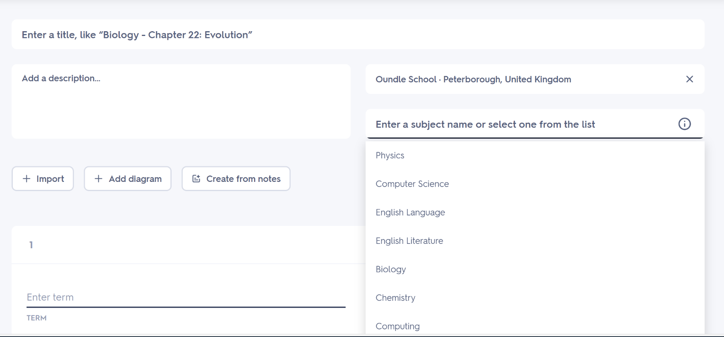Quizlet



I also looked at Quizlet which is a flashcard revision website. I wanted to look at their uploading section because here when they upload there is an option for title, description, school and a list of subjects. I like this and although there are some more things I would ask like difficulty level , and exam board. This setup is aesthetically pleasing and easy to navigate.

OneDrive

I also looked at OneDrive to see how to upload resources on my website.

I liked how they had the different forms at the top I think I will set something similar up on my website. So picture and words to say the type of resource then users click it and scroll to answer the next sections./

#### Different types of material

#### Pdfs (worksheets, notes, teaching material etc)

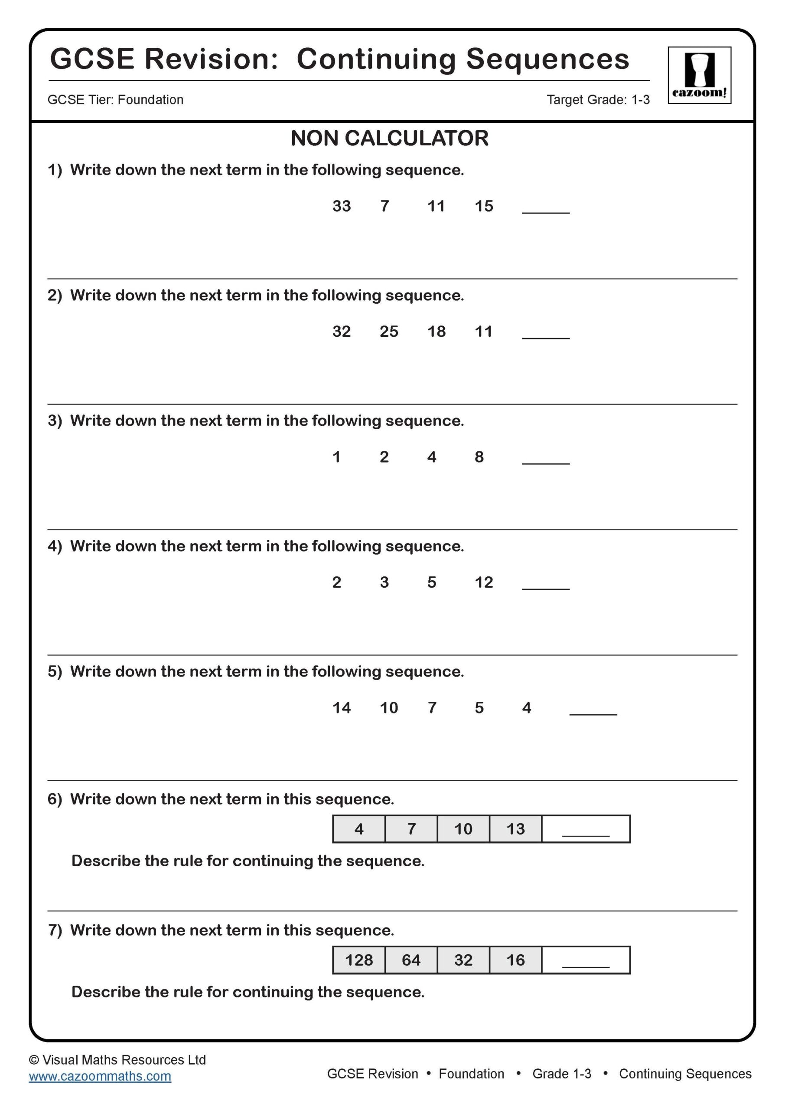This is an example of a maths worksheet , on my website there will be a preview that looks like this then a pdf attached to it that would contain the actual document . this is how pdf’s will be done .

#### Links

Link : [HSK 4 - lesson 1 (with examples) Flashcards | Quizlet](https://quizlet.com/822266519/hsk-4-lesson-1-with-examples-flash-cards/?funnelUUID=d64e0dac-3e59-47fc-ab96-14a8b1f04ced)

For resources where it is a link to something , there will be an option to put a preview image so people can see what they will see before they click the link .

### Essential features of proposed solution

#### User Features

* Users will be able to upload resources such as links and pdfs.
* When a user uploads resources , they will be required to fill in a form with drop down options that ask questions such as : difficulty level , age, resource type , is it for revising or practicing, “are you a teacher or student”, the subject .
* Resources will then be sorted based on what the user answered in the form when uploading it .
* Resources will have tags on them that say whether it is student or teacher created.
* When a user goes on to the home page , there will be a navigation bar that says practice, revise and advice as headers .
* Then the practice and revise section will be sorted so when you click on it there will be options for age/ education level (e.g. GCSE, A-level, SAT), then an option for subjects
* Then an option for difficulty level and resource type .
* In the advice section, there will be sections for subjects and then you can ask a question and people will comment answers .
* So users will be able to see questions asked , ask questions and answer questions that have already been asked .
* The advice section will have all the questions that have been asked then an option to either respond in comment form under a question or to ask a question .
* For the advice section the user will need to create an account before asking a question so that they can get a notification when their question has been answered .
* When a user logs in they will be able to see any questions they have asked and any answers.
* At the bottom on every page , there will be a link to community guidelines and an opportunity to report any breaches
* At the bottom of every page, there will also be a form to report any website glitches and issues so that I can fix them quickly .
* Admins will be able to create an account where they can see when reports are made and have the option remove the question or resource .

### Limitations of my proposed solution

* To protect users details, the site should be hosted with an SSL certificate for encryption purposes and so my website is not flagged as unsafe by web browsers. However these certificated can be very difficult to add and cost money. If there is a surge in users on my website then it can be implemented later on .
* users will not be able to see the recently viewed resources meaning if they leave the website by accident , they can lose what resource they were on. To add this would be too complicated because it would require users to be always logged in on the website and everything they click to be automatically saved or bookmarked .
* I am not going to have a secure website because when I host it I will upload it using free hosting. This might be an issues because of people password’s won’t be secure
* Ensuring the quality and accuracy of the resources shared on the platform could be hard. Without proper moderation or validation mechanisms , there’s a risk of low-quality or incorrect material being uploaded which may undermine the credibility of my website. This could be fixed with a admin monitoring system but that would require every item to be checked which can lead to a lot of hold up of item waiting to be verified and uploaded .
* I also could have a problem with spamming and misuse. My current method relies on users reporting that there is a problem but sometimes people don’t report things.
* Generally the type of website requires a large scale database that is complicated so that will take a lot of time to build and I will also spend a lot of time on the navigation system .

### Hardware and software requirements

#### Hardware

I do not need to buy any hardware for this solution. I will use my own laptop and school monitors when developing the website because it is free and powerful enough. I will use the webserver XAMPP

When I look at hosting options, it will most likely be an external company so I will not need any equipment for that.



Users can use their phones and laptops or tablets to access the website so they don’t need any extra hardware. This means I need to make sure my website works on those types of devices.



#### Software



For the development process, I will use Visual Studio Code because I have used it for other projects So I know it will work well with HTML,CSS,PHP,JS and Bootstrap. I also can put my changes on GitHub easily using Visual Studio Code so I can save my website securely.

I am confident with using HTML and PHP for the actual build and structure of my website and building thing like the navigation bar. I can also use CSS,JS and Bootstrap to make my website more aesthetically pleasing.

I will use XAMPP for a local hosting system , giving me Apache webserver and a MySQL database which can be altered with phpMyAdmin making it very easy for me to edit my database. This Is particularly useful because the database is a huge part of my website and can very complicated very quickly without proper software. XAMPP is free and I have also used it before.

In the future, I will research my option for hosting my website but it is not a priority yet.



For testing it I will need to test it on all sorts of browsers because different browsers have different css effects

Therefore I am confident that the software I have stated here is everything I need to build the website I am imagining .



### Success criteria

* User will be able to easily navigate the website using a navbar at the top.
  + Justification-This will work well for users because it will reduce time when searching for resources. When I did my research I looked at website that had search bars and I concluded that it required too much specificity when searching to actually get good results. Therefore this way is better
  + How I would measure it: how much time does it take to get to a resource, how many clicks. So anything more than 40 seconds or 10 clicks is too much
* When users upload resources , they will fill in a form with drop down options so the resource will be sorted automatically.
  + Justification- This means that I don’t need an admin to manually go through each resource and put it in the right place. The drop down options aspect means that I don’t have to worry about different users spelling things differently and saying the same thing in a different way . This makes the navigation easier and quicker for users because they don’t have to wait for admins to accurately sort everything
  + How I would measure it: if I put ten resources how many are put in the correct place. I would want all in the correct place
* User will be able to upload and access different types of resources
  + Justification- The range of resources will draw more people to my website. As shown when I interviewed people , they do not just want a website with a bunch of pdf documents, they want links and notes and practice worksheets too. Having links as well makes my website more different to others which is useful for search engine order.
  + How I would measure it: how many different resources are available.
* Resources will have tags on them that say whether it is student or teacher created.
  + Justification – I decided on this feature after an interview with a teacher where he said he would want to know whether a resource is made by a teacher or a student . I did not think that there needs to be a whole section that is part of the sorting system for this because then it is too complicated for a user. Especially if the user does not know exactly what they want. Therefore the tags are the best way
  + How I would measure it: how easy is it for the users to see the status of the person that created the resource(rate out of ten).
* Users will be able to see everything sorted thoroughly in the practice and revise sections
  + Justification- Things being sorted by subject, education level and difficulty level will also the user to be specific about what they want and get there quickly. It is also a very easy system to understand and when I interviewed people they appreciated the idea.
  + How I would measure it: can users see all the resources available for that subject and exam board when they click on it.
* Users will be able to see the questions asked, ask question and answer questions
  + Justification- This will help to build a community on the website where people can seek help from different people around the world. I think this will really appeal to students because often it can be hard to ask your teacher for help. This will also appeal to teachers or private tutors because they can get help with planning lessons .
  + How I would measure it: how many questions are asked and what is the typical response time
* Users will have an account for the advice section and will get a notification via email when their question has been answered.
  + Justification-This is so users do not forget about the question they asked because sometimes it might take a while for their question to be answered.
  + How I will measure it: does the email go through to inbox
* There will be a community guidelines sections and the opportunity to make reports if issues.
  + Justification- This is for user safety because people might spam or put inappropriate resources. This allows users to flag admins easily .
  + How I will measure it: what is the response time for reports and it should be within a few days.
* Admins will be see reports made by users and have the option to remove a resource or question
  + Justification- so admins can easily monitor from their account and get reported things checked quickly
  + How I would measure it : can admins see all the reports. Can admins remove a resource within 30 seconds.
* User can report general website issues
  + Justification- This is just to make sure the website is always running smoothly. This is also very easy for admins to sort out
  + How I will measure it: how long does it take to report an issue.

## Design

### Top down diagram

Justification

I have five navbar options because wanted a clear navigation bar to allow to user to see how things work without needing instructions. When the user comes on to the website , they will see a home page with some information about the website and some reviews because I want them to be see the reasons why they should use the website

How the tables link together (one to many , many to many )

Entity relationship diagram

For next step , design the screens for each table .

|  |  |  |  |  |
| --- | --- | --- | --- | --- |
| Field name | Data Type | Validation | Typical Data | Justification |
| User id | INT(8) Primary  Key | Must be exactly 8 digits . autogenerated | 12345678 | Give each unique identifier |
| Name | Varchar(50) | required | Caroline chin | I have chosen 50 characters to ensure the whole name can be stored |
| Email | Varchar(30) | required | Kitandisu07@gmail.com | I have chosen 30 characters to account for longer emails |
| role | Varchar(1) | required | T | This is for if they are a teacher or student . T is for teacher. S is for student. So this only needs to be one character long |

User

Subject

|  |  |  |  |  |
| --- | --- | --- | --- | --- |
| Field name | Data Type | Validation | Typical Data | Justification |
| Subject ID | INT(6) primary key | It has to be 6 digits  autogenerated | 123456 | Give each subject a unique identifier |
| Name | VarChar(40) | Required | Mathematics | I chose 40 characters to ensure even longer subject names can be stored. |

Resource

|  |  |  |  |  |
| --- | --- | --- | --- | --- |
| Field name | Data type | Validation | Typical Data | Justification |
| User ID | INT(8) primary key | Must be 8 characters long. Auto generated. | 12345678 | Give a unique identifier to the user |
| Subject ID | INT(6) primary key | Must be 6 Characters long. Auto generated. | 123456 | Give a unique identifier to the subject |
| Level | Varchar(20) | optional | GCSE | To allows users to see education level |
| Age | Varchar(6) | required | 13+ | To create a unique identifier for the age the resource is suited for . |

Type

|  |  |  |  |  |
| --- | --- | --- | --- | --- |
| Field name | Data Type | Validation | Typical Data | Justification |
| Type ID | INT(8)primary key | Must be 8 character long auto generated | 12345678 | To create a unique identifier for the type of resource |
| format | Varchar(10) | required | pdf | To create |
|  |  |  |  |  |

Post

|  |  |  |  |  |
| --- | --- | --- | --- | --- |
| Field name | Data Type | Validation | Typical Data | Justification |
| Post ID | INT(8)primary key | Must be 8 characters long | 1234678 | To create a unique identifier for different posts |
| User id | INT(8) primary key | Must be 8 characters long | 12345678 | To create a unique identifier for user id |
| Subject id | INT(8) primary key | Must be 8 characters long | 12345678 | To create unique identifier for |
| Question |  | Must be 1 |  |  |
| Date |  |  |  |  |
| Status | Varchar(200) | Must be less than 200 characters | Answered or unanswered | To show whether a post has been answered |

Post id, user id , subject id , comment and time .

Comment

|  |  |  |  |  |
| --- | --- | --- | --- | --- |
| Field name | Data type | Validation | Typical Data | Justification |
| Post id |  |  |  |  |
| User id |  |  |  |  |
| Subject id |  |  |  |  |
| comment |  |  |  |  |
| time |  |  |  |  |

# Development

First thing I need to create a database. I created one called coursework. I used code from previous project just changed my database name.

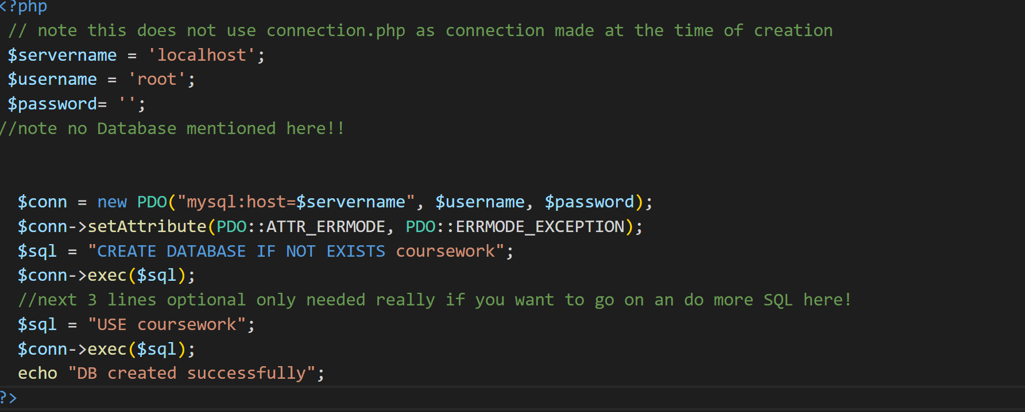

It worked!



I tried to create a table but it didn’t work. This is my code



I realised I put brackets in the wrong place and put a comma after “role varchar(1)” instead of a semi colon.

The fixed code

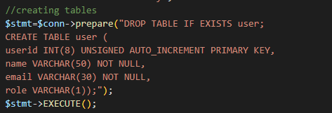



I made a subjects table

